 | Press Release | 
Emergency Text Alerts
: More Information, Fewer Redundancies
- Pilot operation of extended message length (157 characters) and enhanced duplicate-prevention features

The Ministry of the Interior and Safety (MOIS), led by Minister Yun Hojung, is improving the emergency text alert system in a phased manner by expanding message length to deliver sufficient information and by preventing duplicate or excessive transmissions.

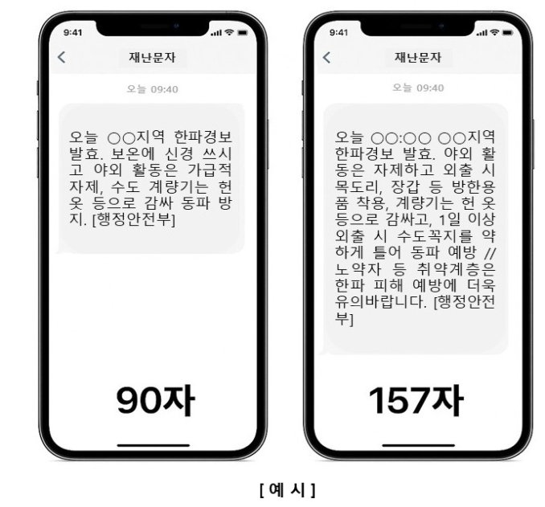
Until now, emergency text alerts have been limited to 90 characters, allowing only brief guidance. Going forward, the length will be expanded to a maximum of 157 characters, enabling the government to provide the public with more detailed and situation-specific disaster information. The 157-character system will undergo pilot operations in four regions, starting Friday, October 31, before being expanded nationwide.

- Pilot areas: Jincheon, Chungcheongbuk-do; Changwon and Tongyeong, Gyeongsangnam-do; and Jeju, Jeju-do
- Target: Non-urgent alerts.

However, the existing 90-character system is maintained for urgent alerts, such as evacuation orders, in consideration of the fact that older mobile phones (released before 2019, approximately 223,000 units as of September 2025) cannot receive 157-character messages.

Another key improvement is the introduction of a pre-transmission duplicate review function to reduce the number of redundant or excessive alerts. This feature automatically detects and flags any duplicate text messages regarding the same type of disaster sent to the same region within 24 hours, prompting the sender to confirm whether they want to proceed with delivery before retransmission. This is expected to enhance public awareness and prevent message fatigue during disasters. The system also provides crucial statistics on duplicate disaster text messages by region, along with a function to view transmission history. The new feature will be piloted in Busan Metropolitan City and Sejong City starting Friday, October 31, and, following verification, will be expanded nationwide in the second half of 2026.

Kim Yong-kyun, the MOIS Deputy Minister of the Safety and Prevention Policy Office, stated, "This update marks a significant milestone in strengthening the effectiveness of the emergency alert system, which will play a vital role in safeguarding citizens' lives and safety. We will continue our efforts to ensure that emergency alerts provide the public with timely and useful safety information."
=============================================================
Inquiries: Deputy Director Jung Woo-Seok (woo81@korea.kr)

 |  | 

